

DFC 6.5
Combined “Functional-Design” Specification
Operations Customization Model
Version 1.2

April 08, 2008
Manisha Umbarje

Revision History
Docbase  Version | Revised  Date | Revised By | Revision  Description
n/a | 12/21/2007 | Manisha Umbarje | Initial draft
n/a | 1/4/2008 | Manisha Umbarje | Included UML diagrams and incorporated feedback from Clay Sebourn.
n/a | 1/9/2008 | Manisha Umbarje | Included new public interfaces such as  IDfPopulatorContext, IDfOperationNodeFactory, IDfOperationNodeTreeBuilder etc.
1.0 | 1/14/2008 | Manisha Umbarje | Included UML Diagram from Sunita.
1.0a | 1/23/2008 | Dennis Dawson | Comments and stylistic corrections.
1.1 | 1/25/2008 | Manisha Umbarje | Removing IDfSessionManager argument from newOperationsManager() on IDfClient.  Adding 3 getter methods on IDfOperation and getOperation method on IDfPopulatorContext.
1.2 | 04/08/2008 | Sunita Casula | Updated instructions on how to implement custom NodeAction and Custom Populator.
Table of Contents
1.0 Introduction 7
1.1 Scope 7
1.2 Overview 7
1.3 D6 and older Operation Entity Definitions 10
2.0 Proposed Operation Entity Definitions 11
2.1 Operation Definition 11
2.2 Populators 12
2.3 Fixed Steps 12
2.3.1 Steps 12
2.3.2 ActionSet 13
2.3.3 Selection Criteria 14
2.3.4 Mandatory Steps 14
2.4 NodeTraversal 15
2.4.1 Default – parent_first 15
2.4.2 child_first 15
2.4.3 none 16
2.5 Operation and Node Context 16
2.5.1 Operation Context 16
2.5.2 Node Context 17
3.0 Design 18
3.1 Instantiating/Executing Operations 18
3.1.1 Instantiating a context aware operation 19
3.1.2 Adding an object to the operation 20
3.1.3 Session Considerations 20
3.1.4 Executing operation 21
3.2 Deploying Operations 21
3.2.1 Intrinsic Modules 22
3.2.2 Customized Modules: 22
3.3 Configuring Operations 23
3.3.1 Operation Definition 23
3.3.1.1 Attr definition: 24
3.3.1.2 Description: 24
3.3.1.3 Operation Module Definition 25
3.3.1.4 populatorset 25
3.3.1.5 steplist 25
3.3.1.6 Ref and id attribute correlation for step/populator and action 25
3.3.1.7 module 26
3.3.1.8 step 26
3.3.1.9 abort_step and finally_step 26
3.3.1.10 actionset 26
3.3.1.11 populator module definition 27
3.3.1.12 Action module definition 27
3.3.1.13 Recommended structure of XML content for an operation 27
3.3.1.14 app.xml modifications for inclusion of qualifiers. 28
3.3.2 Customizations 28
3.3.2.1 Adding a new populator entity definition 28
3.3.2.2 Appending a step 29
3.3.2.3 Adding an actionset 30
3.3.2.4 Replacing an actionset 30
3.4 Implementing Operation Entities (Modules) 30
4.0 Operation Customization Use Cases 31
4.1.1 Context-sensitive Operation Node Governance 31
4.1.2 Context-sensitive Operation Step Application 32
4.1.3 Operation Extension 32
5.0 External Interfaces 33
5.1 Modified Interfaces and Classes 33
5.1.1 IDfClientX and DfClientX 33
5.1.2 IDfClient and DfClient 34
5.1.3 IDfOperation 34
5.1.4 IDfPopulator 35
5.2 New Interfaces and Classes 36
5.2.1 IDfOperationManager 36
5.2.2 IDfPopulatorContext 36
5.2.3 IDfOperationNodeFactory 37
5.2.4 IDfOperationNodeTreeBuilder 38
5.2.5 IDfOperationEdge 40
5.2.6 IDfStepAction 41
5.2.7 IDfOperationContext 42
5.2.8 DfGenericOperation 42
5.2.9 Implementations of com.documentum.services.config.IQualifier 42
5.2.10 Implementations of com.documentum.services.config.IConfigReader 42
5.2.11 Implementation of com.documentum.services.config.IConfigRefreshListener 43
5.3 Eliminated Interfaces and Classes 43
5.3.1 IDfObjectNodeInternal 43
6.0 Test Strategy 43
7.0 Supportability/Diagnostics Engineering 44
8.0 Future Expansion 44
9.0 Referenced Documents 44
Appendix A – UML Diagrams 45
Create Operation Sequence Diagram 45
Node population using add() 46
Execution of operation 47
Appendix B - Configuration Samples 48
Import Operation Definition 48
Appending a step for a particular domain 49
Inserting a populator 50
Replacing an action set 50
Mapping.xml 51
Appendix C – Sample Custom Populator 53
Appendix D - Unit Tests 55

Table of Figures

Figure 1 Operation (Node-based) Population and (Step-based) Execution 9
Figure 2 : 6.5 Runtime node specific behavior 18

Introduction

Scope
This document details the design for supporting customization of Documentum Foundation Classes (DFC) operations by prescribing a new (i.e., first-time) customization model for DFC operation clients. Configuration, Deployment and runtime concerns will also be discussed herein.
This document does not concern itself with Unified Client Facilities (UCF) and therefore doesn’t discuss content transfer, content analysis packages (e.g., content detectors), etc. That being said, DFC operations clients such as the Web Development Kit (WDK) do combine their use of DFC operations with UCF; however, UCF refactoring is beyond the scope of this design.
DFC operations customization in the D6.5 release is only for use internally by EMC product teams. It is not intended, yet, for general customer use. Documentation should be produced to allow internal EMC product teams to be productive against the new model, but no public documentation of the model should be provided.
However, please do note that there is a difference here between consumption and modification where this model is concerned. None of the customization model should be publicly documented to enable customers to modify DFC operations. However, there absolutely should be public documentation that covers all consumption aspects of the new/modified interfaces.
IDfClient's (new) newOperationManager method and the new IDfOperationManager interface (etc.) should be publicly documented along with deprecating other accessors (e.g., IDfClientX.getXxxxOperation)—as you’ll see further on in this document, below.

Overview
D6 Operations Package captures details of 6.0 DFC operations processing as performed without the proposed customization model (i.e., hard-wired operations processing in the DFC 6.0 code base); basic concepts are discussed here, as they are important for understanding the new proposed model.
To be absolutely clear, the hard-wired processing that exists in D6 and prior releases will continue to function as-is in the Documentum 6.5 (D6.5) release. Clients written against this hard-wired process API before D6.5 will continue to work without change during D6.5 development and after D6.5 ships. However, these clients will not automatically participate in the new customization model proposed here.
Existing and new DFC operations client must explicitly move toward the new customization model in order to receive its benefits. This specification intends to provide such clients with a clear path toward customization model adoption.
In general operation-centered process flow proceeds as follows with the hard wired approach:
IDfClientX client = new DfClientX();
//Create an import operation
IDfImportOperation importOperation =
client.getImportOperation();
// Set operation parameters
importOperation.setKeepFile(true);
// setSession is important mainly for import operation to // indicate repository to import files to
importOperation.setSession(targetRepositorySession);
//Add a file or folder to be imported
IDfOperationNode node =
importOperation.add(“path to a file/folder”);
// Set object name of the imported object
node.setNewObjectName(“new object”);
//Execute operation
importOperation.execute();

- Given the present approach, an operation instance is obtained (e.g., via the appropriate factory method on IDfClientX—that is, getXxxxOperation). At this point there are no nodes in the operation (i.e., the operation is not a node itself).
- Operation parameters are set to control subsequent processing behavior (e.g., setXxx methods on the object from step #1 to change pre-defined (default) behavior). Some parameters are mandatory for a particular operation.
- Specific operands are provided (e.g., document inputs for operation via its add method). Each successful addition is represented by a new operation node instance.
- Node parameters are set, on a per node basis, to control subsequent node-specific processing behavior. Parameters applied to a node affect that node and its descendants.
- The operation is executed (i.e., operation’s execute method is invoked). Execution of the operation may add and process additional nodes (e.g., scanning an XML document for links may add linked documents to the associated operation). The execute method returns a Boolean value to indicate its success (true) or failure (false). That is, operations may return errors; operations do not throw exceptions. Operation execution results in executing multiple steps in sequence.
- Results from the operation are processed (i.e., errors are handled and higher-level tasks specific to the operation are performed).
Already a number of key concepts have been revealed: operation, parameter, operand, node and result. Behind the scenes, additional entities are busy at work as follows: step, edge, package, populator and monitor. All of these entities are described in Section 1.3.
To better understand the relationship between population (add) and execution, please consider the following diagram.
Figure 1 Operation (Node-based) Population and (Step-based) Execution

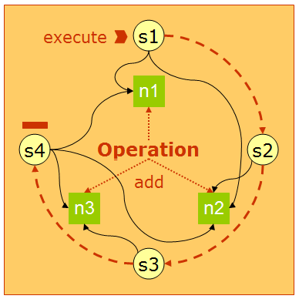

The above diagram indicates that operation.add() results in creating operation nodes n1, n2 and n3. operation.execute() results in executing steps s1, s2, s3 and s4 in sequence. A step might not operate on all nodes. For instance, s3 operates only on node n3 while s4 operates on all the nodes.
With D6, there is not a straightforward way of customizing operations. The list of available operations is fixed. The number of steps and their order in an operation is fixed. The implementation of a particular operation (i.e., the associated Java class) is fixed. The list of acceptable populators for an operation is fixed.
Context is currently not taken into account within the current DFC operations code.
Today there are new challenges and opportunities that cause us to revisit customization support. For example (non-exhaustive):
- Archiving Services for Email (E5)
- Knowledge Worker
- Web Services for Content Management (“WS4CM”)
- Service-Oriented Architecture (SOA)

D6 and older Operation Entity Definitions
This section will attempt to provide a clearer definition for entities and concerns surrounding operations—with the expectation that public documentation is revised accordingly. Configuration of almost all the following entities come from a file – DfOpResourcesText.properties bundled with dfc.jar .
- Operation – the embodiment of content-centric processing. An operation acts upon one or more nodes according to specified operational parameters—for the entire operation and/or for a specific node. An operation executes one or more steps in a specified order.
  - Inbound operation – an operation that applies to content entering a Documentum-controlled repository (e.g., import, check in)
  - Outbound operation – an operation that applies to content leaving a Documentum-controlled repository (e.g., export, check out)
- Node – an abstract representation of a sysobject or a file (i.e., the actionable essence of an operation, which contains a structure of nodes and descendants). More than one node can point to the same sysobject or file. For an import operation, node representation corresponds to a file; otherwise, it corresponds to sysobject.
- Step – a logical unit of execution. An operation is executed as a series of steps. Each step may have a corresponding node action.
- Node action – a logical unit of execution. A node action is independently performed on a node in an operation.
- Step Action – a logical unit of execution that does not apply to any node. An example of a step action is cleaning up Windows registry entries.
- Populator – mechanism that supports the creation of nodes that an operation is applied against. An operation contains a structure of nodes and descendants. When you obtain an operation, it has no nodes (i.e., DFC does not regard the operation itself as a node). When you use an operation’s add method to add documents or other content items to the operation, it creates new root nodes. The add method is the populator for the operation. For example, DfAddFolder iterates through all the files and subdirectories in a folder and adds them as nodes to an import operation. There are other out of box populators for adding sysobjects, virtual documents, files, etc. Lists of populators are visited from top to bottom until a populator accepts the responsibility of creating one or more nodes based on given object.
- Package (and package item) – mechanism that supports more efficient operations by supplying all the necessary information up front (rather than in two phases). Content packages have an affinity toward operations (e.g., IDfImportContentPackage for IDfImportOperation). Once the content package is created, a file or a sysobject (depending on the type of operation) is added to the content package. A corresponding package item is created for the added file or sysobject. One can then set all the necessary information on the content package and/or content package item(s). Once all the information is set, content package should be added to the operation. The populator for content package iterates over all the content package items in the content package and creates node(s) for the corresponding content package item(s).
- Edge – an abstract representation that depicts the relationship between two nodes (e.g., in the case of VDM, an edge corresponds to dmr_containment). This entity is not entirely implementation detail and isn’t configurable.
- Monitor – mechanism that supports operation progress indication. An operation monitor provides access to operation errors as they occur and allows for abort/continue decisions in real time.
The rest of this specification will describe a design to introduce customization support to DFC operations that may be accomplished declaratively in XML-based configuration.

Proposed Operation Entity Definitions
Most of the current operation entity definitions apply to the new design with some modifications and additions as described below. Note that configuration for operation entities now would be defined in XML files. With the new model, DfOpResourcesText.properties would not be bundled with dfc.jar. DFC uses Config Service module for reading the XML configuration files. More details on configuration is described in Configuration section.

Operation Definition
An operation is defined in the following manner in an XML file. More details on individual elements in XML are described below and in the Configuration Section.
<scope>
<operation id="import" KeepLocalFile="true" CanUndo="true"
DebugDumpOnExecute="false">
<description>DFC import operation</description>
<operationmodule>
<operation_primary_class
name="com.documentum.operations.inbound.DfImportOperation"/>
</operationmodule>
<abortstep ref="abort_import"/>
<finallystep ref="finally_import"/>
<populatorset>
<populator ref="package_populator"/>
<populator ref="directory_populator"/>
<populator ref="file_populator"/>
</populatorset>
<steplist id="import_step_list">
<step ref="import_post_population"/>
<step ref="import_housekeeping"/>
<step ref="import_pre_processing"/>
<step ref="import_object_processing"/>
<step ref="import_container_processing"/>
<step ref="import_cleanup"/>
<step ref="import_post_processing"/>
</steplist>
</operation>
</scope>

The operation definition (i.e., lists of populators, steps, etc.) is determined from the contextual information provided as part of the instantiation of the operation. See the Instantiation section for more details.

Populators
An operation specifies a list of populators in a configuration file as follows.
<scope>
<operation id=”import”>
…
<populatorset>
<populator ref="package_populator"/>
<populator ref="directory_populator"/>
<populator ref="file_populator"/>
</populatorset>
</operation>
</scope>

Populators are responsible for creating all the nodes. However, to maintain backward compatibility, in the cases like importing compound documents, all the data to create new nodes may not be available until the operation is executed. So an additional step, referenced as import_post_population, will be provided to populate additional nodes to the import operation. Note that this approach is strictly used to maintain backward compatibility and this spec does not recommend additional node population during execution of steps.
Populators are executed from top to bottom until a populator is successful in populating a node. The list of populators is decided based on the operation context provided at the time the operation is instantiated. A customization may insert its own populator in the set of available populators and so can alter the sequence of the populators.

Populators are recursive. For instance, a populator responsible for populating a directory yields control back to the operations framework to populate the list of files contained in the directory as opposed to the hard-coded approach in the D6 design. See the modifications to IDfPopulator section for more details.

Fixed Steps
Every operation has a fixed list of steps to be executed during runtime just as in the D6 approach. However, a step may result in a different sequence of actions based on selection criteria such as the repository type of the object and/or the format of the file being imported. These criteria are described in the section Selection Criteria ,below. The list of steps for an operation is determined early on, at the time of instantiation of an operation, based on provided contextual information.

Steps
Steps in the new design are more like templates or broad categories that are fixed for an operation. Every operation defines a sequence of steps. Here is an example of the list of steps for an import operation:
<operation id=”import”>
…
<steplist>
<step ref=”import_post_population”
<step ref=”import_pre_processing”/>
<step ref=”import_object_processing”/>
<step ref=”import_container_processing”/>
<step ref=”import_post_processing”/>
</steplist>
</operation>
Steps are always executed top to bottom. That implies that all the nodes in the operation have to finish executing a particular step successfully before the next step begins. In the example above, the nodes generated by adding a dm_folder, dm_document, and virtual document have to execute import_post_population before moving to import_pre_processing.
These steps cannot be reordered, deleted or replaced. However, customizations can append a step to the list of already defined list of steps by an operation. For example, a customization may need an additional Auditing functionality as a last action for an operation.

ActionSet
A step can have only one action set for a node. An actionset can have zero or more actions. All the actions in an actionset will be applied to a particular node before proceeding to the next node. For example, if in an operation contains two nodes, NodeA of non dm_folder type (for example, dm_sysobject) and NodeB of type dm_folder, with following step definition
<scope>
<step id=” import_object_processing”>
<actionset>
<action ref=”create_new_obect”/>
<action ref=”set_content_file"/>
<action ref="apply_detected_attrs"/>
<action ref="fix_up_containments"/>
<action ref="checkin_object"/>
</actionset>
</step>
</scope>

<scope type="dm_folder">
<step id="import_object_processing">
<actionset>
<action ref="create_new_folder_object"/>
<action ref="apply_detected_attrs"/>
<action ref="checkin_object"/>
</actionset>
</step>
</scope>

the order of execution mandates that NodeA will process create_new_obect, set_content_file, apply_deteced_attrs, fix_up_containments, and checkin_object before NodeB starts execution of applicable actionset – create_new_folder_object, apply_detected_attrs, and checkin_object. Execution of a step results in executing the applicable actionset, based on selection criteria. An actionset can be added or replaced by customizations. Look at the Configuration section for related examples.

Selection Criteria
The actionset may differ for every operation node. An actionset is determined at runtime based on two broader categories - repository type and format. For example, during import DfApplyXmlForImport is called only if the file format is xml. These two selection criteria are specified on populator and step elements.
ConfigService’s scope mechanism is used to provide selection criteria for a particular actionset. A node may provide appropriate contextual information for supporting dynamic look up of actionset. Below is an example of step definition.
<scope format=”xml”>
<step id=”import_post_population”>
<actionset>
<action ref=”DfApplyXmlForImport”/>
</actionset>
</step>
</scope>
<scope type=”dm_folder>
<step id=”import_object_processing”>
<!—this action set applies to only dm_folder operation
nodes ->
<actionset>
<action ref=”create_new_folder”/>
<action ref="DfApplyDetectedAttrs"/>
<actionset>
</step>
</scope>
<scope>
<step id=”import_object_processing”>
<!—This action set is applicable to all non dm_folder
operation nodes ->
<actionset>
<action ref=”create_new_obect”/>
<action ref=”set_content_file"/>
<action ref="DfApplyDetectedAttrs"/>
</actionset>
</step>
</scope>
Look at the Node Context section, below, for more details.

Mandatory Steps
A finally_step is specified at the operation level. It is always executed at the end of the step sequence in success as well as error situations. Theoretically, this function is similar to the finally clause in Java.

An abort_step followed by a finally_step is executed in case of abnormal termination of an operation due to some error condition. Below is an example of abort_step and finally_step.
<scope domain=”email_archive”>
<operation id=”import”>
<abort_step ref=”import_abort_step”
>
<finally_step ref=”import_finally_step”/>
….
</operation>
</scope>

NodeTraversal
Most steps process parent nodes before processing their children. But folders require a child to be deleted before the parent; to accomplish this, a traversal order is specified on an action set.
The following kinds of traversals will be provided out of the box.

Default – parent_first

Parent is always processed before processing a child node.

<scope>
<step id=”object_processing”>
<!—this implies parent is processed before its children ->
<actionset>
<action ref=”delete_object”/>
</actionset>
</step>
</scope>

child_first

Children are processed before processing parent node. This applies during a Delete operation on a folder.

Example of delete folder:
<scope type=”dm_folder”>
<step id=”object_processing”>
<actionset node_traversal_order=”child_first”>
<action ref=”delete_object”/>
</actionset>
</step>
</scope>

none
This implies that all the actions in the actionset are step actions and are not executed on nodes.
<scope>
<step id="import_housekeeping" >
<actionset node_traversal_order="none">
<action ref="house_keeping"/>
</actionset>
</step>
</scope>

Operation and Node Context
Client application provides contextual information before instantiating an operation. Operation Definition (that is, the list of populators and steps, abort step, and finally step for the operation are decided early on, based on this operation context). ActionSet is selected at runtime, depending on some information derived from the nodes by the operations framework. See the section node context for more details.

Operation Context
With the new model, it is possible to instantiate a context aware operation by providing the contextual information at the time of creating the operation as below.

IDfOperationManager om = DfClient.newOperationManager();
String domain = “kw”;
IDfOperationContext context =
om.newOperationContext(domain);
IDfSession session = sm.getSession(repname);
IDfOperation operation = om.newOperation(operationName, context, session);

The string provided for creating newOperationContext() helps determine the correct operation definition in case there are multiple definitions for an operation, as shown below.
// om.newOperationContext("kw");
<scope domain="kw">
<operation id="import">
…
</operation>
</scope>

// om.newOperationContext("email_archiving");
<scope domain="email_archiving">
<operation id=import>
…
</operation>
</scope>

The value provided to newOperationContext() should map to the domain attribute of the scope element around the operation definition.

A null value for context, such as

IDfOperation operation = om.newOperation(operationName, null, session);
results in the retrieval of a default operation definition; that is, an Operation definition that is not scoped by providing additional attribute key-value pair as shown below:
<scope>
//om.newOperation("import", null, session);
<operation id="import">
…
</operation>
</scope>

Node Context
A node can provide selection criteria to help determine the list of actions to be executed as part of a step execution at runtime. For example, during an import operation instantiation, the client app or a populator can use IDfImportNode’s setFormat() or setDocbaseObjectType() to provide format, type, or both.
- Repository type: maps to the type attribute for the scope element surrounding the step definition
- Format: maps to a format attribute for the scope element surrounding the step definition
If type and format are not specified on the node by the client app or populator, the operations framework attempts to determine these values. For instance, if a file is being imported, the file extension is used for the format. At runtime, these values are used to choose the list of actions to be executed for the given step and the given node.
For instance, adding a folder to an import operation can result in multiple nodes, each corresponding to a different file format. If a folder contains a .txt and an .xml file, nodes corresponding to those files would provide format=”txt” and format=”xml” respectively. At runtime, DfAppXMLForImport is executed for node corresponding to the .xml file, while no actions are executed for the “.txt” file.

Following are some samples of steps scoped by these attributes.
<scope format="xml">
<step id="import_post_population">
<actionset>
<action ref="DfApplyXMLForImport"/>
</actionset>
</step>
</scope>

<scope>
<step id="import_post_population">
<actionset/>
</step>
</scope>

Figure 2 : 6.5 Runtime node specific behavior
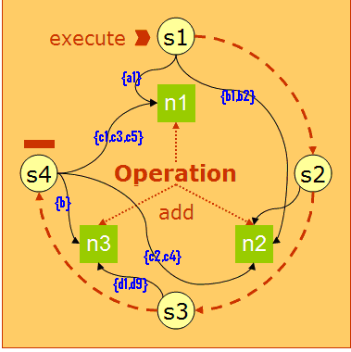

The above diagram depicts how node specific actions are executed ( indicated by {..}) with 6.5 model.

Design
The following sections detail the proposed design by considering the following operation lifecycle:
- Implement (Section 3.4)
- Configure/declare (Section 3.3)
- Deploy/register (Section 3.2)
- Instantiate/execute (Section 3.1)
In the next set of sections, the order of design detail (i.e., instantiate first and implement last) is intentionally reversed. The sections are listed from an end user’s (i.e., client/caller developer’s) perspective.

Instantiating/Executing Operations
[Operation lifecycle: implement → declare/configure → deploy/register → instantiate/execute]

Instantiating a context aware operation
The essential flow talked about in Section 1.2 continues to be valid. However the recommended/promoted factory APIs will change under this new model. Instead of calling a getXxxxOperation factory method on IDfClientX, operation clients will call IDfClient.newOperationManager. From the returned IDfOperationManager interface, clients will leverage factory methods for operation-related entities—context and operations in particular. IDfOperationManager.getOperation becomes the (single) recommended factory method for operations in this new model.
IDfOperationManager.newOperation encapsulates invocation of configuration service to lookup operation entities. This new service will leverage the existing BOF deployment model and will therefore support hot deployment of newer implementations dynamically (e.g., updated XML configuration files to reset/refresh the operation entity configuration DOM).

IDfOperationManager.getOperation will process a context input parameter, name of the operation and session handle to drive its interaction with the config service. Context is represented by a new IDfOperationContext interface and is retrieved/established via the new IDfOperationManager.newOperationContext method. For more information, review Operation Context section. and the Operation Creation UML Diagram in Appendix A.
For example, client code might trigger custom operation processing as follows:

IDfClient client = new DfClient.getLocalClient();
IDfOperationManager om = client.newOperationManager();
String domain=”kw”;
IDfOperationContext context = om.newOperationContext(domain);
IDfSession session = sm.getSession(repositoryName);
IDfOperation operation = om.getOperation(operationName, context,
session);

The operation context will first determine what operation instance to return to the caller. Unlike the current implementation, which always returns the same instance for all calls for the same operation name, context may dictate that, for example, a particular line of business (domain) requires a particular operation instance other than the default operation instance for the same name (e.g., “import”). Passing “null” for context will cause the operation manager to create a default (empty) context object and associate it with the returned operation. The operationName argument maps to the operation definition’s id attribute in the configuration file.
A non-null session value is required to retrieve the configuration of custom operation entities from a repository; otherwise, DfOperationNotDefinedException is thrown for non-default DFC operations.
A null value for the session argument indicates that only DFC’s default operations config files are searched for looking up the operation corresponding to the provided context.
Client code might trigger default (i.e., not dependent upon context) operation processing as follows:

IDfClient client = new DfClient.getLocalClient();
IDfOperationManager om = client.newOperationManager();
IDfOperation operation = om.newOperation(operationName, null, null);

Please see the following sections for code-level details:
- Section 5.1.2 regarding IDfClient interface and DfClient class modifications
- Section 5.2.1 regarding the new IDfOperationManager interface and the new DfOperationManager class
- Section 5.1.3 regarding IDfOperation interface and DfOperation class modifications
- Section 5.2.2 regarding the new IDfOperationContext interface and the new DfOperationContext class

Adding an object to the operation
Invocation of the following code from a client application results in looping through the list of populators until a populator is successful in adding an operation node for the object. See the add() UML diagram in Appendix A.

IDfOperationNode node = operation.add(object);

Session Considerations
If getOperation() is invoked with a valid session parameter, the operation definition is looked up in the corresponding repository. A null value for session in a getOperation() indicates that the application should look up the default operation configurations bundled with dfc.jar.

IDfSession session = sm.getSession(repositoryName);
IDfOperation operation = om.getOperation(operationName, context,
session);

If getOperation() was invoked with a non-null value for the session argument, the following method invocation will result in an IllegalStateException runtime exception for a non-matching value.

operation.setSession(session);

Successful invocation of setSession() can result in using session specific populators, if configured. With the new operations customization model, it is recommended that setSession() is invoked before invoking add() for instant population of nodes. Backward compatibility for client applications invoking add() before the setSession() method, nodes are populated lazily at the time of execution of operation instead of at the time of add(). With the D6 approach, only in case of adding a package item for inbound operation or outbound operation, setSession() needs to be invoked before invoking add() for that package item.
An operation may involve interacting with multiple repositories for outbound operations such as export, checkout, or for inbound operations by setting the destination folder id on different nodes to folders from different repositories as a result of execution of the operation.
For instance, documents from different repositories can be exported in the same operation

operation.add(new DfId(“0900000100000101”));
operation.add(new DfId(“0900000200000101”));

For inbound operations, the session indicated by the folderId specified using the node.setDestinationFolderId(folderId) method takes precedence over any other method of specifying a session, such as setSession().

Executing operation

operation.execute();

Execution of an operation results in executing all the steps specified by operation definition from top to bottom. Operations framework executes applicable action sets on every node for a step before proceeding to the next step. A step can result in entirely different action sets for every node involved in the operation. An execution of an operation can affect multiple repositories. See the Operation Execution UML diagram in Appendix A.

Deploying Operations
[Operation lifecycle: implement → declare/configure → deploy/register → instantiate/execute]
In short, operation entities in the new model are all BOF-based modules. The operation entities should fully participate in current tooling, packaging and deployment as other BOF modules do today. That is:
- Repository-based registration of modules
- Modules packaged as DocApps via Application Builder (DAB)
- DocApps installed via Application Installer (DAI)
To summarize, a BOF module is a unit of executable business logic and its supporting material (for example, documentation, third party software, and so forth). A detailed discussion of BOF, DocApps, DAB and DAI is beyond the scope of this document. Please consult published content for any of these concerns.

Intrinsic Modules
All default DFC operation entities are deployed as intrinsic modules along with Config Service. Configuration files for default operations are available as part of dfc.jar.

Customized Modules:
Customized operation entities are repository-specific BOF modules. It may happen that while base operation definition is sourced from dfc.jar, customizations are provided by specific repository modules. For example, to support importing EMCMF (EMC Messaging format) files, an additional populator and node action is required. These additional customizations are deployed on the repository that supports the EMCMF related docapp.
Customized BOF modules are deployed under the /System/Modules/Operations folder in a repository, while supporting configuration files for these modules are deployed under /System/Operations/config folder in the repository.
The name of these operation entities must be unique across a particular repository. So, where there may be more than one deployed implementation for a particular operation according to a different scoping/qualification, each implementation must have a different package name. Calls for modules are serviced via IDfClient.newModule, and the module name expected by either method must match a deployed module package name (e.g., “com.acme.engineering.Import”).
However, the client of the operation should not know about these specific names. Rather, it should only be concerned with the common, essential name of the operation it requires (e.g., “import” versus “com.acme.finsrv.Import,” “com.acme.hr.Import,” or “com.acme.engineering.Import”).
The Config Service’s scope element is used to map the operation context provided during instantiation of the operation to a unique operation definition and unique module names for all entities of that operation. It maps a generic name to a unique name depending on context. For example:
import + {domain=engineering} → com.acme.engineering.Import
import + {domain=human_resources} → com.acme.hr.Import
The unique name will be passed to newModule, and the resulting module will be returned to the IDfOperationManager.getOperation caller.
Subsequent client calls to the resolved operation instance will also leverage the Config Service underneath (e.g., determination of steps, available populators, and actionsets).
For example,
<action id="copy_objects">
<module
name="com.documentum.operations.nodeactions.DfCopyObject"/>
</action>

<populator id="sysobject_populator">
<module
name="com.documentum.operations.populators.DfSysObjectPopulator"/>
</populator>

For more details concerning the XML-based declaration of operation entity configuration and operation wiring configuration, see Section 3.3.

Configuring Operations
[Operation lifecycle: implement → declare/configure → deploy/register → instantiate/execute]
Class map and operation entries in the classic, hard-wired table, DfOpResourcesText.properties, will be replicated and enhanced by entity-specific XML files using Config Service-supported XML elements. For more details on Config Service see the specification at http://beauty2.documentum.com/webtop/drl/objectId/0900000180659594 .

Operation Definition
All the operation entities, including the operation definition, are scoped using the scope element. An example of the operation element is shown below.
<scope>
<operation id="export" KeepLocalFile="true" CanUndo="false"
DebugDumpOnExecute="false" UpdateRegistryType="None"
GetFilePathFromRegistry="false">

<description>DFC export operation</description>
<operationmodule>
<operation_primary_class
name="com.documentum.operations.outbound.DfExportOperation"/>
</operationmodule>
<abortstep ref="abort_export"/>
<finallystep ref="finally_export"/>

<populatorset>
<populator ref="package_populator"/>
<populator ref="sysobject_populator"/>
<populator ref="vdm_populator"/>
</populatorset>

<steplist>
<step ref="export_pre_processing"/>
<step ref="export_compond_document_processing"/>
<step ref="export_object_processing"/>
<step ref="export_container_processing"/>
<step ref="export_post_processing"/>
</steplist>
</operation>
</scope>

Operation entity definition includes

Attr definition:

<operation id="export" KeepLocalFile="true" CanUndo="false"
DebugDumpOnExecute="false" UpdateRegistryType="None"
GetFilePathFromRegistry="false">

The id attr is a mandatory attribute that specifies the name of the operation. For example, id=“export”. The value of the id attribute must be unique among all operation entity definitions. This value is used by the client application at the time of instantiation of the operation
operationManager.getOperation(operationName, context,session)
An operation definition may include additional attribute declarations, if necessary.

Description:

<description>DFC export operation</description>
Text element describing the operation

Operation Module Definition
Represents a BOF module for the operation. The name attribute of operation-primary-class is used at the time of instantiation of the operation and maps to the name of one of the BOF modules.
<operationmodule>
<operation-primary-class
name="com.documentum.operations.outbound.DfExportOperation"/>
</operationmodule>

populatorset
This is a list of populators executed from top to bottom until a populator is successful in adding a node.
<populatorset>
<populator ref="package_populator"/>
<populator ref="sysobject_populator"/>
<populator ref="vdm_populator"/>
</populatorset>

steplist
This is a list of steps executed from top to bottom when operation.execute() is invoked.
<steplist>
<step ref="export_pre_processing"/>
<step ref="export_compond_document_processing"/>
<step ref="export_object_processing"/>
<step ref="export_container_processing"/>
<step ref="export_post_processing"/>
</steplist>

Ref and id attribute correlation for step/populator and action
The ref attribute is used for referencing step/populator/action definitions.

Note that the ref attribute indicates that it is a reference to definition specified using the id attribute in another portion of the XML on the same element, similar to a Java reference. For example, in the above operation definition, the populator reference using ref=”package_populator” is defined as below
<populator id="package_populator">
<description>
This populator is used for populating a package item. </description>
<module name="com.documentum.operations.populators.DfPackagePopulator"/>
</populator>

module
<module
name="com.documentum.operations.populators.DfPackagePopulator"/>

Each module element represents a BOF module – either intrinsic or repository-specific. This name is used at the time of instantiation of the operation element. In example above, it is used at the time of instantiation of the export operation.

step
step is defined as below, usually surrounded by a scope element. Note that step defines only one action set for a particular scope.
<scope format="xml">
<step id="export_container_processing">
<actionset>
<action ref="apply_xml_for_export"/>
</actionset>
</step>
</scope>

abort_step and finally_step

<abort_step ref="import_abort_step"/>
<finally_step ref="import_finally_step"/>

Refer to Proposed Entity Definition section for more details on meaning of these mandatory steps. Also see the ref and id correlation section.

actionset
An actionset is surrounded by a step element. An actionset defines a list of actions to be executed from top to bottom that satisfies the selection criteria surrounding the step definition. An actionset without node_traversal_order implies that the actionset should use the default parent_first node traversal order. Possible values for the node_traversal_order attribute on actionset are parent_first, child_first and none.
<scope format="doc,xsl,ppt">
<step id="export_container_processing">
<!—this action set is applicable for operation nodes whose format is one of doc, xsl or ppt. ->
<actionset node_traversal_order=”parent_first”>
<action ref="patch_file_refs"/>
</actionset>
</step>
</scope>

<scope>
<step id="export_container_processing">
<!—This action set, which is empty for this step, is applicable to nodes by default ->
<actionset/>
</step>
</scope>

populator module definition

A populator is defined as below. See the module, ref and id correlation sections for more details.
<populator id="package_populator">
<description>
This populator is used for populating a package item. </description>
<module name="com.documentum.operations.populators.DfPackagePopulator"/>
</populator>

Action module definition

An action is defined as shown. See the module, ref and id correlation sections for more details.
<action id="emcmf_update_action">
<description>
This module is used to update a dmc_message_archive message.
</description>
<module name="email.xtender.EmcmfUpdateAction"/>
</action>

Recommended structure of XML content for an operation
Although all the above configuration XML elements can be specified in an XML file for configuring an operation, we recommend that operation definition is specified in one file while module definitions are specified in another xml file so that module definitions can be shared across operations, as shown in Appendix B. A customization can define all operations in a single XML file, or can distribute individual operation definitions in separate files. A customization can also choose to define step definitions in a single file. An example follows.
<config version="1.0">
<scope type="dm_folder">
<step id="import_object_processing">
<actionset>
…
</actionset>
</step>
<step id="export_object_processing">
<actionset>
…
</actionset>
</step>
</scope>
</config>

app.xml modifications for inclusion of qualifiers.
The following three qualifiers are supported with this release of DFC. These qualifiers are specified in app.xml for the Config Service.

<config version="1.0">
<scope>
<application>
<qualifiers>
<qualifier>
com.documentum.operations.config.qualifiers.DomainQua
lifier
</qualifier>
<qualifier>
com.documentum.operations.config.qualifiers.FormatQualifier
</qualifier>
<qualifier>
com.documentum.services.config.qualifiers.DocbaseTypeQualifier
</qualifier>
</qualifiers>
</application>
</scope>
</config>

DomainQualifier is responsible for mapping value of operation context, while FormatQualifier and DocbaseTypeQualifier are responsible for interpreting node context.

Customizations
Customizations use the modifies construct of the Config Service to modify a base configuration by changing the order of existing populators, adding an entity definition, or by replacing an existing operation entity.

Adding a new populator entity definition
An insertion point extension of Config Service is used to support customization of operation entities using the following Config Service definitions. For more details on these constructs, check out 1.6 section of Config Service Spec available at http://beauty2.documentum.com/webtop/drl/objectId/0900000180659594
In operations customization context, insertbefore and insertafter constructs are used for inserting a customized populator before or after a referenced populator.
For example, if the base configuration is
<scope>
<operation id=”import”>
...
<populatorset>
<populator ref="package_populator"/>
<populator ref="directory_populator"/>
<populator ref="file_populator"/>
</populatorset>
</operation>

</scope>

with the following configuration, populators are visited in package_populator, directory_populator, EmcmfPopulator and file_populator order.
<scope>
<operation modifies="import:application='operations'">
<insertbefore
path="populatorset.populator[ref=file_populator]">
<populator ref="EmcmfPopulator"/>
</insertbefore>
</operation>
<populator id="EmcmfPopulator" extends="application='operations'">
<module name="com.documentum.email.EmcmfPopulator"/>
</populator>
</scope>

Appending a step
Note that insertbefore/insertafter constructs are not used for customizing steps as an existing list of steps cannot be reordered. Customization can append a step to the existing list as below, using an insert construct.
<scope>
<operation modifies="import:application='operation'">
<insert path="steplist">
<step ref="import_audit"/>
/insert>
</operation>
<step id="import_audit">
<actionset>
<action ref="audit"/>
</actionset>
</step>
<action id="audit">
<module name="custom.actions.AuditAction"/>
</action>
</scope>

If the base configuration is

<operation id=”import”>
…
<steplist>
<step ref=”import_post_population”
<step ref=”import_pre_processing”/>
<step ref=”import_object_processing”/>
<step ref=”import_container_processing”/>
<step ref=”import_post_processing”/>
</steplist>
</operation>

The above customization modifies the import operation to include the import_audit step as the last step, resulting in execution of import_post_population, import_pre_processing, import_object_processing, import_container_processin, import_post_processing and import_audit steps as part of the operation.execute() invocation.

Adding an actionset

The following is an example of adding an actionset.

<scope type=”dm_message_archive”>
<step id=”import_object_processing”>
<actionset>
<action ref=”call_sbo/>
</actionset>
</step>
</scope>

Replacing an actionset
A customization can replace an already defined action set for a step using the replace construct.
The following is a base definition for the step import_object_processing for nodes of repository type dm_message_archive.

<scope type="dm_message_archive">
<step id="import_object_processing">
<actionset>
<action ref="call_sbo"/>
</actionset>
</step>
</scope>

The following is a customization that replaces the existing action set definition for step
import_object_processing for a node of repository type dm_message_archive.

<step modifies="import_object_processing:application='operations'
type='dm_message_archive'">
<replace path="actionset">
<actionset>
<action ref="call_new_sbo"/>
</actionset>
</replace>
</step>

Implementing Operation Entities (Modules)
[Operation lifecycle: implement → declare/configure → deploy/register → instantiate/execute]
As discussed in Section 3.2, all operation entities are now BOF modules (i.e., simple modules). This means that existing non-BOF operation implementations should be revised to support BOF tooling, packaging and deployment (i.e., become first class BOF modules).

In summary, the following development approach is recommended:
- Implement modules for the required operation entities i.e., populators and actions.
- A customized populator should extend from the class DfPopulator. DfPopulator implements IDfPopulator interface. Example: public class MyPopulator extends DfPopulator
An custom action should extend from the class DfNodeAction.
DfNodeAction implements IDfNodeAction. Example: public class MyNodeAction extends DfNodeAction.
- Package and deploy the modules from step #1 into specific repository(-ies) as appropriate under the /system/modules/operations folder.
- Write appropriate the XML file, indicating the customization associated with the module from step #2 and deploy it under the /system/operations/config folder in the same repository(-ies) as in step #2. Some samples for customizations are included in Appendix B.
- Exercise IDfOperationManager-focused unit tests to confirm that the fully deployed operation can be instantiated as expected.

It is important to note that without special design-time tools that are not planned as part of this specification, there exists a loose relationship between the entity ids declared and referenced in config files and the actual deployed entities.
All modules should be packaged and deployed according to BOF guidelines and mandates (e.g., separate interface and implementation JAR files, etc.).

Operation Customization Use Cases
This section focuses on use cases that describe likely forms of customization enabled by this proposed model.

Context-sensitive Operation Node Governance
Existing clients should require no change to leverage the benefit of richer behavior due to the addition of new populators over time. Examples include but are not limited to the following:
- Yesterday only a {package}.AddSysObject populator existed for dm_message_archive-based content, but today a {package}.AddMessageArchive populator is available to govern similar content where operations upon it are concerned.
- Only AddSysObject yesterday but Zip/Cab/Tar-aware populator today
  - Open Document Format (ODF) support for Open Office
  - Office Open XML support for Office 2007
  - eCTD, DITA, etc. support for accessing an archive then importing individual files contained therein
In both examples, the client issues the same service calls, regardless of issue date.
More on the Archiving Services for Email (E5) Use Case
When Archiving Services for Email (E5) is initially released, the Documentum platform portion will be BOF-based. Consequently, customization of email archiving functionality is also BOF-based. While this may be reasonable for EmailXtender (EX) and Documentum Client for Outlook (DCO), it poses a problem for horizontal clients such as Webtop that depend on DFC operations support for types like dm_message_archive.
In fact, the Client group has levied the following requirement on the Server group in this regard: “Operations package will construct [an] HTML rendition (like DCO) and transparently return this like any other rendition.” That is, DFC operations must support HTML renditions of dm_message_archive content without requiring special client/application logic to interact directly with the current BOF-based implementation of email archiving support.
The Gang of Four (GoF) defines the Façade pattern as providing “a unified interface to a set of interfaces in a subsystem. Façade defines a higher-level interface that makes the subsystem easier to use.” Therefore, DFC operations leveraging this proposed customization model become effective façades where message archive content is concerned.
The details concerning the design of this customization for platform clients such as Webtop are beyond the scope of this specification.

Context-sensitive Operation Step Application
Within a particular enterprise, ECM business logic may dictate that all document check in operations should effectively produce PDF renditions. This business can:
- Declare in its XML-based operations configuration that within a dm_document (type) scope, check in operations include an extra step to create a rendition.
- Deploy the new configuration to the relevant repositories.
- See the creation of renditions from subsequent client requests to check in against the revised operations model for the target repository.

Operation Extension
It is often better to reuse than to build. Leveraging existing assets reduces the amount of code to maintain, reduces the time to solution and benefits from quality improvements made by the source of the reused code. The Knowledge Worker team may be using some of the operation entities for copying/moving data table.

External Interfaces
Many of the UML diagrams in this document are hard if not impossible to read at 100% size. However, Word does support view sizing up to 500%, and at this size all diagrams do appear to be legible (with a fair bit of scrolling).

The following interfaces and classes are affected by this proposed customization model.
New elements are noted in green text. Deprecated elements are noted in grey text.

Modified Interfaces and Classes

IDfClientX and DfClientX
While the type safety brought about by getXxxxOperation methods and IDfXxxxOperation interfaces, etc. is valued, it does not scale to a world that needs to create new operations based on DFC—either from scratch or specialized based on an existing operation. For example, without a change to the DFC programming model, a DFC client must know about more than one operation factory (i.e., IDfClientX and something else). Operation factories outside of IDfClientX may be customer-provided or they may be provided by third parties (e.g., partners, systems integrators, consultants, etc.) Consequently, factory management can become a major burden to DFC client developers and their IT administrators.
Therefore, existing operation factory methods on IDfClientX will be deprecated and a new factory method on IDfClient, newOperationManager, will be provided and promoted.
public interface IDfClientX
{
. . .
public IDfOperation getOperation(String operationName) throws DfException;
. . .
public IDfImportOperation getImportOperation() throws DfException;

public IDfCheckinOperation getCheckinOperation() throws DfException;

public IDfExportOperation getExportOperation() throws DfException;

public IDfCheckoutOperation getCheckoutOperation() throws DfException;

public IDfCancelCheckoutOperation getCancelCheckoutOperation() throws DfException;

public IDfCopyOperation getCopyOperation() throws DfException;

public IDfDeleteOperation getDeleteOperation() throws DfException;

public IDfMoveOperation getMoveOperation() throws DfException;

public IDfXMLTransformOperation getXMLTransformOperation() throws DfException;

public IDfValidationOperation getValidationOperation() throws DfException;
. . .
}
DfClientX-based implementations of the above methods will be revised to leverage the new mechanism detailed in the following sections:
- Section 5.1.2 – IDfClient and DfClient
- Section 5.2.1 – IDfOperationManager

IDfClient and DfClient
To localize operation-related creation requests by clients, a new factory method will be added to the IDfClient interface, newOperationManager, as follows:
package com.documentum.fc.client;

import com.documentum.fc.common.*;
import com.documentum.fc.client.search.IDfSearchService;
import com.documentum.operations;

import java.util.Enumeration;

public interface IDfClient
{
. . .
public IDfOperationManager newOperationManager() throws DfException;

}
The implementation of the new IDfClient.newOperationManager method in the base class DfClient will follow the pattern established for service (SBO) creation as follows:
private operation final String OPERATION_MANAGER = "com.documentum.operations.impl.DfOperationManager";

public IDfOperationManager newOperationManager() throws DfException
{

return (IDfOperationManager)this.newModule(OPERATION_MANAGER, sessionMgr);

}
Please see Section 5.2.1 for more details concerning the new IDfOperationManager interface and the new DfOperationManager class.

IDfOperation
The primary interface for operations, IDfOperation, will be extended to support context-awareness and the BOF deployment model.
package com.documentum.operations;

public interface IDfOperation
{
. . .

public boolean areDisabledRegistryUpdates ();

public boolean isEnabledPopulateWithReferences ();

public IDfOperationMonitor getOperationMonitor();

public IDfOperationContext getContext();

}
Classic IDfOperation implementations can create no-op implementations of the new IDfOperation methods. New IDfOperation implementations (i.e., those availing themselves to the customization model) can specify real processing.

IDfPopulator

IDfPopulator will be modified to support the following protocol as a part of this project,

public interface IDfPopulator
{

public IDfOperationNode process(Object object);

public void setContext(IDfPopulatorContext context);

public IDfPopulatorContext getContext();

}
Currently, this recursion is hard coded using an if/then/else statement. For example, consider the following folder hierarchy,
MainFolder
Subfolder
File1.txt
File2.xml
In D6 code, during export, the DfAddFolder populator calls the populator for either a {folder,virtual document,sysobject} depending on the type/format of the document, similar to…

operation.getPopulator(IDfOperationPopulator.VIRTUAL_DOCUMENT).add(virtualDoc, folderNode,operationEdge);

In the new design, when the populator needs to recursively process its contents, it yields control back to the operations framework. The operations framework then uses an accept/decline pattern to resolve a populator for each of the subcomponents.

New Interfaces and Classes

IDfOperationManager
package com.documentum.operations;

public interface IDfOperationManager implements IDfModule
{
IOperation getOperation(String operationName, IDfOperationContext context, IDfSession session) throws DfOperationNotDefinedException;

IDfOperationContext newOperationContext(String contextId);
}
IDfOperationManager.newOperation expects a string-based name, a context object and a session. “Null” is acceptable for context and session, and if “null” is passed the IDfOperationManager implementation will create a default (empty) context. The passed or provided context will be used to return the appropriate IOperation implementation and the context will be associated with this implementation—accessible by the caller via IOperation.getContext.
The name passed to newOperation cannot be “null” or an empty string. In order to return an IOperation implementation, operationName must also be recognized by the IDfOperationManager implementation and must be correctly deployed accordingly to BOF rules and conventions.
A “null” session results in reading the configuration from dfc.jar instead of a customized operation definition.

IDfPopulatorContext

package com.documentum.operations;

/**
* This interface provides access to other objects that are
* responsible for creating or building a node tree. It is used by
* populators to support node population.
*/
public interface IDfPopulatorContext
{
/**
* Returns a factory that can create IDfOperationNode objects
* @return IDfOperationNodeFactory factory object for creating
* nodes.
*/
public IDfOperationNodeFactory getNodeFactory();

/**
* Returns an object that is responsible for building a node tree.
* @return IDfOperationNodeTreeBuilder a node tree builder object.
*/
public IDfOperationNodeTreeBuilder getNodeTreeBuilder();

/**
* Returns the operation object.
*/
public IDfOperation getOperation();

}

IDfOperationNodeFactory

There is one node factory for every operation object.

package com.documentum.operations;

import com.documentum.fc.common.IDfId;
import com.documentum.fc.common.DfException;
import java.io.File;

/**
* A factory object used by populators to create a node or an edge for
* given objects.
*
*/
public interface IDfOperationNodeFactory
{
public IDfOperationNode newNode(IDfId id) throws DfException;

public IDfOperationNode newNode(File file)throws DfException;

/**
*
* @param parentId parent object's id
* @param childId child object's id
* @param edgeType One of the following values: dmr_containment,
* dm_relation, folder_link, dm_assembly
* @return IDfOperationEdge
*/
public IDfOperationEdge newEdge(IDfId parentId, IDfId childId, String edgeType) throws DfException;
}

IDfOperationNodeTreeBuilder
This operation traverses a list of populators for an operation until a populator can build an operation node for that object. This interface is used by both the operation, when the add() method is invoked on it, and by a populator when it needs to recursively add related objects. For instance, a directory populator will invoke add(parentNode, edge, contained_file) for all files contained in that directory. There is one population helper for every operation object.

package com.documentum.operations;

/**
* Responsible for iterating through list of populators for building
* and managing a node tree for the operation.
* IDfOperationNodeTreeBuilder acts as a bridge to business logic
* for node population using IDfPopulator and the operation.
*
* When a client application invokes
* operation.add(object);
* internally, nodeTreeBuilder.add(object) is invoked. At that time,
* the list of configured populators is visited until a populator
* assumes responsibility of populating a node for that object.
* A populator may invoke
*
* nodeTreeBuilder.add(parentNode, edge, obj)
*
* for all child objects. For instance, a directory populator would
* invoke add(parentNode, edge, obj) for all files contained in it.
* Or a populator might also invoke the add(obj) method in case it
* decides that a particular logical child object should be added
* as a root node.
*
*/
public interface IDfOperationNodeTreeBuilder
{
/**
* This method adds a node for the corresponding object as a root
* node. This method can be invoked from either an operation or a
* populator to add root nodes. It visits list of populators until one can process the object successfully by populating node for it.
*
* @param obj
* @return IDfOperationNode root node in the node tree of the
* operation.
*/
public IDfOperationNode add(Object obj);

/**
* Appends a node for the corresponding object as a child node for
* the given parentNode by iterating through a list of
* populators for the operation. This method is called from
* populators only.
*
* @param parentNode A parent node, for instance, in case of adding
* a directory for import operation, results in adding a node for
* the directory itself and child nodes for the contained files.
*
* @param edge An operation edge represents the relationship
* between a parent node and the node being added as result of
* the execution of this method.
* @param obj Object for which a node needs to be created
* @return IDfOperationNode The node corresponding to a given obj.
*/
public IDfOperationNode add(IDfOperationNode parentNode, IDfOperationEdge edge, Object obj);

}

IDfOperationEdge
Represents the relationship between nodes being created by the populator.

package com.documentum.operations;

import com.documentum.fc.common.IDfId;
import com.documentum.fc.common.IDfProperties;

/**
* An edge represents the relationship between parent a
* IDfOperationNode and a child IDfOperationNode. It can be one of the
* following types: dmr_containment, dm_relation, folder_link,
* dm_assembly. A populator uses this interface to supply the
* relationship between various nodes it is creating. Properties on the
* edge are usually used by node Actions.
*/
public interface IDfOperationEdge
{
/**
* The object id of the repository object corresponding to the
* parent node.
* @return
*/
public IDfId getParentId ();

/**
* The object id of the repository object corresponding to the
* child node.
* @return
*/
public IDfId getChildId ();

/**
* Returns one of the following repository types as a string:
* dmr_containment, dm_relation, folder_link, dm_assembly
*
* @return String;
*/
public String getType ();

/**
* Additional properties, such as copy behavior, version label,
* etc., can be set on the IDfProperties using this method.
* @return IDfProperties
*/
public IDfProperties getProperties ();

}

IDfStepAction

package com.documentum.operations;

/**
* A customization needs to implement this interface to include a
* non node-specific, action such as housekeeping, cleaning of the
* registry, etc.
*/
public interface IDfStepAction
{
public boolean execute();
public IDfProperties getProperties();
}

IDfOperationContext

package com.documentum.operations;

public interface IDfOperationContext
{
String get(String);
void set(String name, String obj);

}
Operation Context applies to only one operation at any given time.
Internal implementation IOperationContext implements the Config Service’s required IContext interface and extends IDfOperationContext.

public interface IOperationContext extends IDfOperationContext, IConfigContext
{
}

DfGenericOperation
This BOF module can be used for new custom operations. It provides a generic implementation of IDfOperation interface.

package com.documentum.operations;

public class DfGenericOperation implements IDfOperation
{
}

Implementations of com.documentum.services.config.IQualifier
Two new qualifiers – com.documentum.operations.config.qualifiers.FormatQualifier for supporting format will be introduced. For supporting docbase type, com.documentum.operations.config.qualifiers.DocbaseTypeQualifier is reused. com.documentum.operations.config.qualifiers.DomainQualifier will be introduced to support context-aware operation instantiation.This qualifier maps operation context information provided for operation instantiation to the domain attribute’s value for the scope tag surrounding the operation definition.

Implementations of com.documentum.services.config.IConfigReader
com.documentum.operations.config.impl.reader.JarReader is a class that reads default operations-related config files from dfc.jar. For reading configurations from a repository, com.documentum.services.config.reader.DocbaseConfigReader will be reused.

Implementation of com.documentum.services.config.IConfigRefreshListener
com.documentum.operations.config.impl.OperationsConfigRefreshListener will be introduced to dynamically load new/modified configurations from one or more repositories.

Eliminated Interfaces and Classes
In general, all existing (“classic”) operation-related entities in DFC will exist in DFC 6.5 in such a way that existing DFC clients will continue to work against DFC 6.5.

IDfObjectNodeInternal

It is expected that the Java DMCL project will effectively make the current IDfBasicAttributes functionality leveraged by VDM and by operations obsolete. Since IDfObjectNodeInternal only provides a getPersistentProperties method that returns an IDfBasicAttributes reference, IDfObjectNodeInternal will become obsolete as well. APIs dealing in IDfObjectNodeInternal will instead deal in IDfObjectNode.

Test Strategy
In general, testing will occur on the following fronts: functionality, usability and performance.
- Functional Testing: All the existing D6 JUnit tests must work with the new model.
- Backward compatibility testing: If the global registry is 5.3/6.0 and DFC is 6.5, the existing tests should still work.
- New tests will be written for the customization model such as
  - new custom operations
  - new custom populators
  - appending a step
  - new custom actions
  - replacing an action set
- Performance is a big factor here. For example, XML access should be benchmarked. Keep in mind that flexibility and performance may be on opposite sides of the same coin (trade-offs)—e.g., hard-wiring vs. configuration-based wiring/re-wiring, but performance should have higher priority. The good news about performance is that we have a great functional specification to baseline (i.e., DFC 6.0 in action).

Supportability/Diagnostics Engineering
This proposed customization model will integrate with and leverage standard (log4j-based) DFC tracing and logging facilities.

Future Expansion

With 6.5, defining a new custom operation is not exposed using this model. Post 6.5, it would be nice to provide an ability to define new operations, and custom extensions of IDfOperation and IDfOperationNode.
In preparation for future external distribution of these new operations, and to facilitate their use by BMTs, all new interfaces and classes will have complete, thoroughly reviewed Javadoc.

Referenced Documents
Requirements
- Documentum Foundation Classes Development Guide 6.0, EMC | Documentum Technical Publications, August 2007
  - i.e., current operations coverage
- DFC 6.0 Operations Package Design
- Config Service
- BOF2 Functional Specification, Alexander et al, 2005 i.e., current module coverage
- Discuss DOCM, CMSG_Server eRoom discussion area for this specification, 2006

Appendix A – UML Diagrams

Create Operation Sequence Diagram

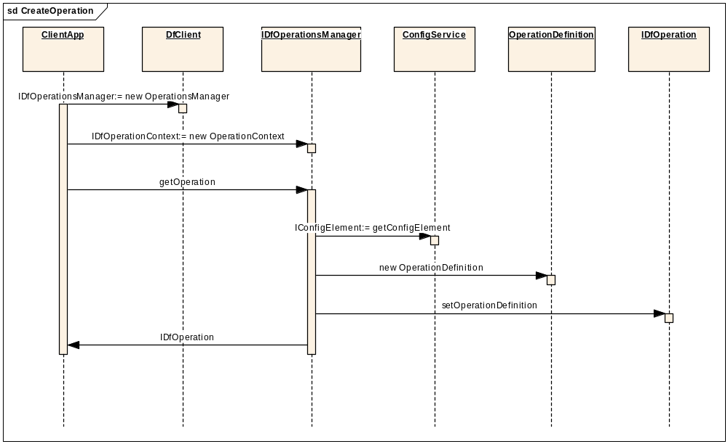

Node population using add()

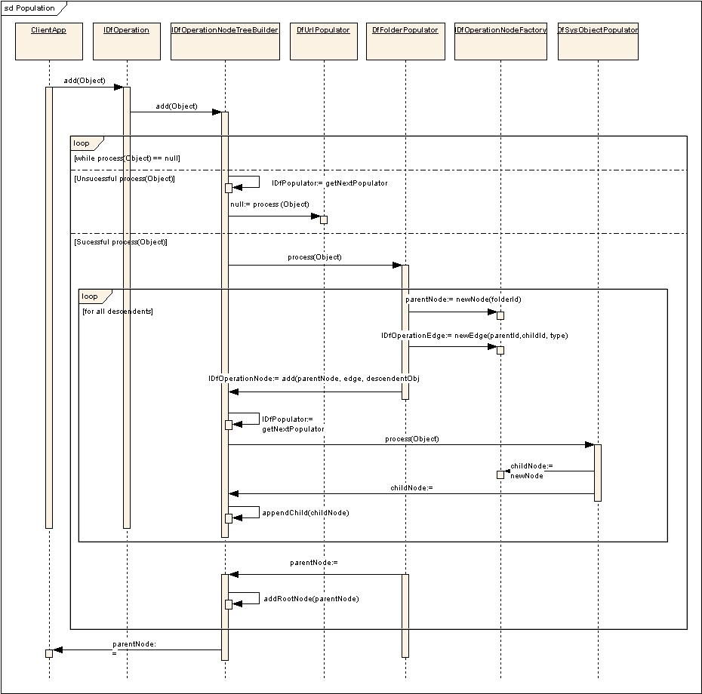

Execution of operation

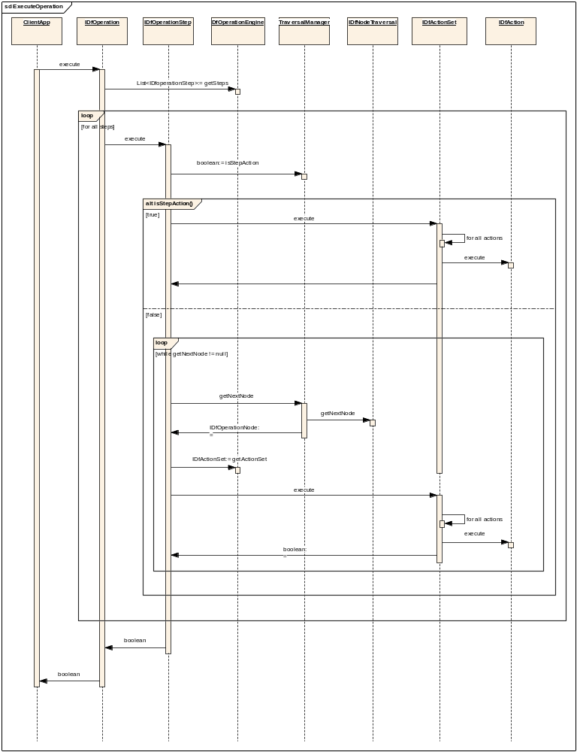

Appendix B - Configuration Samples

Import Operation Definition

<?xml version="1.0" encoding="UTF-8" standalone="no"?>

<config version=”1.0”>
<scope>
<operation id="import" KeepLocalFile="true" CanUndo="true" DebugDumpOnExecute="false">
<description>DFC import operation</description>
<operationmodule>
<operation_primary_class
name="com.documentum.operations.inbound.
DfImportOperation"/>
</operationmodule>
<abortstep ref="abort_import"/>
<finallystep ref="finally_import"/>
<populatorset>
<populator ref="package_populator"/>
<populator ref="directory_populator"/>
<populator ref="file_populator"/>
</populatorset>
<steplist>
<step ref="import_post_population"/>
<step ref="import_housekeeping"/>
<step ref="import_pre_processing"/>
<step ref="import_object_processing"/>
<step ref="import_container_processing"/>
<step ref="import_cleanup"/>
<step ref="import_post_processing"/>
</steplist>
</operation>

<step id="import_post_population">
<actionset/>
</step>

<step id="import_housekeeping" >
<actionset node_traversal_order="none">
<action ref="house_keeping"/>
</actionset>
</step>

<step id="import_pre_processing">
<actionset>
<action ref="pre_checkin"/>
</actionset>
</step>

<step id="import_object_processing">
<actionset>
<action ref="create_new_object"/>
<action ref="set_content_file"/>
<action ref="apply_detected_attrs"/>
<action ref="fix_up_containments"/>
<action ref="checkin_object"/>
</actionset>
</step>

<step id="import_container_processing">
<!-- fix_up_relations and clean_up_local_file step do not apply for dm_folder and its subtype-->
<actionset>
<action ref="fix_up_relations"/>
<action ref="clean_up_local_file"/>
</actionset>
</step>

<step id="import_cleanup" >
<actionset node_traversal_order="none">
<action ref="cleanup_temporary_files"/>
<action ref="remote_registry_instructions"/>
<action ref="flush_registry"/>
</actionset>
</step>

<step id="import_post_processing">
<actionset node_traversal_order="none">
<action ref="add_new_object_id_to_package_item_map"/>
</actionset>
</step>

</scope>

<scope format="xml">
<step id="import_post_population">
<actionset>
<action ref="apply_xml_for_import"/>
</actionset>
</step>
</scope>

<scope format="doc,xls,ppt">
<step id="import_post_population">
<actionset>
<action ref="add_referenced_files"/>
</actionset>
</step>
</scope>

<scope type="dm_folder">
<step id="import_object_processing">
<actionset>
<action ref="create_new_folder_object"/>
<action ref="apply_detected_attrs"/>
<action ref="checkin_object"/>
</actionset>
</step>
<step id="import_container_processing">
<actionset/>
</step>
</scope>
</config>

Appending a step for a particular domain
<?xml version="1.0" encoding="UTF-8" standalone="no"?>

<config version=”1.0”>
<scope domain="foo">
<operation modifies="import:application='operation'">
<insert path="steplist">
<step ref="import_audit"/>
</insert>
</operation>
<step id="import_audit">
<actionset>
<action ref="audit"/>
</actionset>
</step>
<action id="audit">
<module name="custom.actions.AuditAction"/>
</action>
</scope>
</config>

Inserting a populator

<?xml version="1.0" encoding="UTF-8" standalone="no"?>

<config version=”1.0”>
<scope>
<operation modifies="import:application='operations'">
<insertbefore
path="populatorset.populator[ref=file_populator]">
<populator ref="EmcmfPopulator"/>
</insertbefore>
</operation>

<populator id="EmcmfPopulator"
extends="application='operations'">
<module name="com.documentum.email.EmcmfPopulator"/>
</populator>
</scope>
</config>

Replacing an action set
<?xml version="1.0" encoding="UTF-8" standalone="no"?>

<config version=”1.0”>
<scope>
<step modifies="import_object_processing:application='operations'
type='dm_message_archive'">
<replace path="actionset">
<actionset>
<action ref="call_new_sbo"/>
</actionset>
</replace>
</step>
<action id="call_new_sbo">
<module name="call.new.sbo"/>
</action>
</scope>
</config>

Mapping.xml
A common mapping.xml configuration file holds module id to BOF module mapping. We recommend that developers separate operation definition from module mappings for clarity and reuse. The following XML file contains examples of actions related to various operations such as copy, delete, etc. Custom operations can also define their own mapping.xml file.

<?xml version="1.0" encoding="UTF-8" standalone="no"?>

<config version='1.0'>
<scope>

<!-- Populator list -->
<populator id="sysobject_populator">
<module
name="com.documentum.operations.populators.DfSysObjectPopul
ator"/>
</populator>

<populator id="directory_populator">
<description> Populates directory structure from the file system.</description>
<module
name="com.documentum.operations.populators.DfDirectoryPopul
ator"/>
</populator>

<populator id="package_populator">
<description> Package Populator</description>
<module
name="com.documentum.operations.populators.DfPackagePopulat
or"/>
</populator>
<action id="house_keeping">
<module
name="com.documentum.operations.stepactions.DfHouseKeeping"/>
</action>
<action id="pre_checkin">
<module
name="com.documentum.operations.stepactions.DfPreCheckin"/>
</action>
<action id="abort_import">
<module
name="com.documentum.operations.stepactions.DfAbortImport"/
>
</action>
<action id="create_new_folder_object">
<module
name="com.documentum.operations.nodeactions.inbound.Df
CreateNewFolderObject"/>
</action>
<action id="create_new_object">
<module
name="com.documentum.operations.nodeactions.inbound.DfCreat
eNewObject"/>
</action>
<action id="set_content_file">
<module
name="com.documentum.operations.nodeactions.inbound.DfSetCo
ntentFile"/>
</action>
<action id="apply_detected_attrs">
<module
name="com.documentum.operations.nodeactions.DfApplyDetected
Attrs"/>
</action>
<action id="fix_up_containments">
<module
name="com.documentum.operations.nodeactions.inbound.DfFixUp
Containments"/>
</action>
<action id="fix_up_relations">
<module
name="com.documentum.operations.nodeactions.inbound.DfFixUp
Relations"/>
</action>
<action id="add_referenced_files">
<module
name="com.documentum.operations.nodeactions.inbound.Df
AddReferencedFiles"/>
</action>

<action id="checkin_object">
<module
name="com.documentum.operations.nodeactions.inbound.DfCheckinObject"/>
</action>
<action id="clean_up_local_file">
<module
name="com.documentum.operations.nodeactions.impl.DfCleanUpL
ocalFile"/>
</action>
<action id="cleanup_temporary_files">
<module
name="com.documentum.operations.stepactions.DfCleanupTempor
aryFiles"/>
</action>
<action id="remote_registry_instructions">
<module
name="com.documentum.operations.stepactions.DfRemoteRegistr
yInstructions"/>
</action>
<action id="add_new_object_id_to_package_item_map">
<module
name="com.documentum.operations.stepactions.DfAddNewObjectI
dToPackageItemMap"/>
</action>
<action id="apply_xml_for_import">
<module
name="com.documentum.operations.nodeactions.inbound.impl.DfApplyXMLForImport"/>
</action>
<action id="flush_registry">
<module
name="com.documentum.operations.stepactions.DfFlushRegistry"/>
</action>
<action id="finally_import" type="step">
<module
name="com.documentum.operations.stepactions.DfFinallyImport
"/>
</action>
</scope>
</config>

Appendix C – Sample Custom Populator

package com.documentum.operations.populators;

import com.documentum.operations.*;
import com.documentum.fc.common.DfProperties;
import com.documentum.fc.common.DfException;
import com.documentum.fc.common.IDfProperties;
import java.io.File;

/**
* This populator is responsible for creating a node for the directory
* as well as all files contained in the directory.
*/
public class DfDirectoryPopulator implements IDfPopulator
{
public DfAddDirectory () throws DfException
{
m_properties = new DfProperties();
}

public IDfOperationNode process(Object newObject) throws
DfException
{
if(newObject == null)
return null;

File fileSpec = null;

// Try several strategies for creating a File object.

// If we have a string, try to make a File object.
if (newObject instanceof String)
{
fileSpec = new File((String) newObject);
}
else if(newObject instanceof IDfFile)
{
// If we have an IDfFile, try to make a File object.
fileSpec = new File(((IDfFile) newObject).getFullPath());
}
else if (newObject instanceof File)
{
// If available, use an existing File object.
fileSpec = (File) newObject;
}

// If we can’t create a file object, return a null value.
if (fileSpec == null)
{
// Return to caller.
return null;
}

// Create the folder node to the opeartion.
IDfOperationNode newNode =
_context.getNodeFactory().newNode(fileSpec);

// Set the property indicating that this is a file system
// directory.

newNode.getProperties().putBoolean("IS_DIRECTORY", true);

//add children
addDescendents(fileSpec, newNode);

// Return to caller.
return newNode;
}

/**
* Method called recursively to add the contents of a directory to
* the operation.
*
* @param fileSpec directory to be added.
* @param folderNode parent folder node of the node to be
* added; null for root level nodes.
*
*/
private void addDescendents (File fileSpec, IDfOperationNode
folderNode) throws DfException
{
// Get the contents of the directory/folder.
File[] fileList = fileSpec.listFiles();

// Iterate over the contents of the directory/folder.
//
for (int i = 0; i < fileList.length; i++)
{
// Get the next file.
File fileObj = fileList[i];
// Create an edge between for parent of type folder_link.
IDfOperationEdge edge =
m_context.getNodeFactory().newEdge(folderNode.getId()
, null, "folder_link"); m_context.getNodeTreeBuilder().add(folderNode,edge,fileObj);
}
}

public IDfProperties getProperties()
{
return m_properties;
}

public void setContext(IDfPopulatorContext populatorContext)
{
m_context = populatorContext;
}

public IDfPopulatorContext getContext()
{
return m_context;
}

private DfProperties m_properties;
private IDfPopulatorContext m_context;
}

Appendix D - Unit Tests
As coding is completed, this appendix will be updated with the set of Unit Tests prepared for and applied to the developed code. A standard for Unit Testing has been developed and will govern the scope of Unit Testing.

[End of Document]

Most of the content of this section comes from Craig’s 6.0 Design spec available at http://beauty2.documentum.com/webtop/drl/objectId/0900000180623df8.
Existing APIs remain but might be deprecated. Their implementation will change to call the new common factory infrastructure.
i.e. operations, operation populators, actions
i.e. what is within the curly braces represents the state of an IDfOperationContext object
“BOF2” is short for the second major release of the Business Object Framework (i.e. the 5.3 release of BOF).

